**Lab: Blind SQL injection with conditional errors**

**Problem:** **The results of the SQL query are not returned, and the application does not respond any differently based on whether the query returns any rows. If the SQL query causes an error, then the application returns a custom error message.**

**Goal:** **The database contains a different table called users, with columns called username and password. You need to exploit the blind SQL injection vulnerability to find out the password of the administrator user.**

**Solve:**

**Note :**

**True🡪receive error**

**False🡪 the same page**

**1-orcale os**

**2-**

**3-**

4-there is a user called administrator

5-

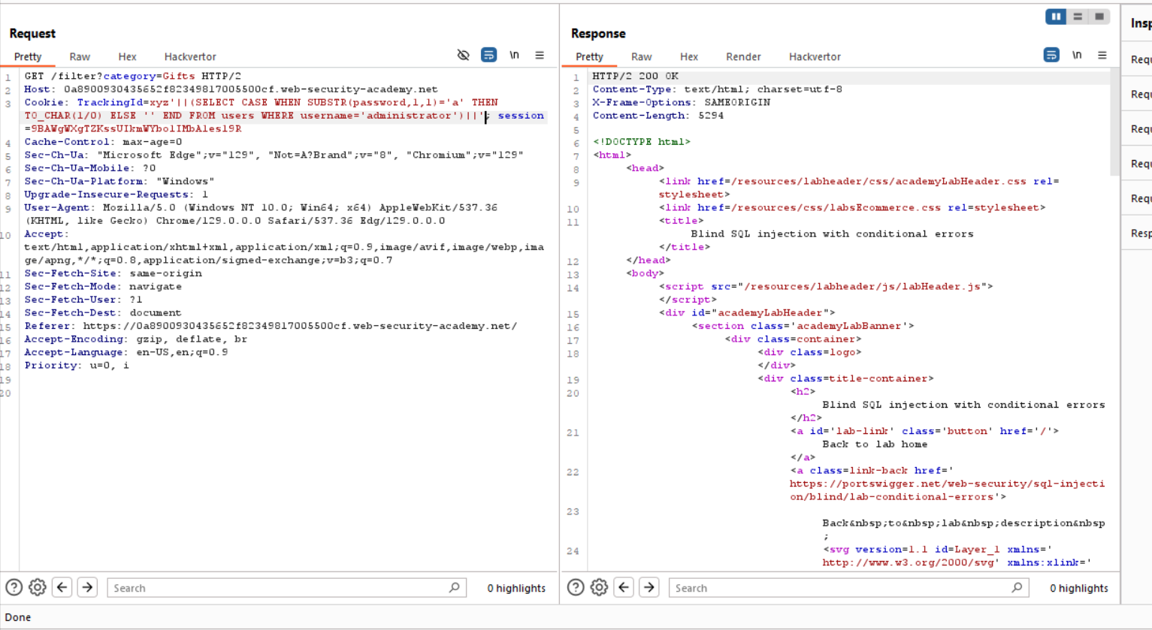

6- 0-9 , a-z

Then the password🡪 20 char

5-

6-

7-We choose the code 500

